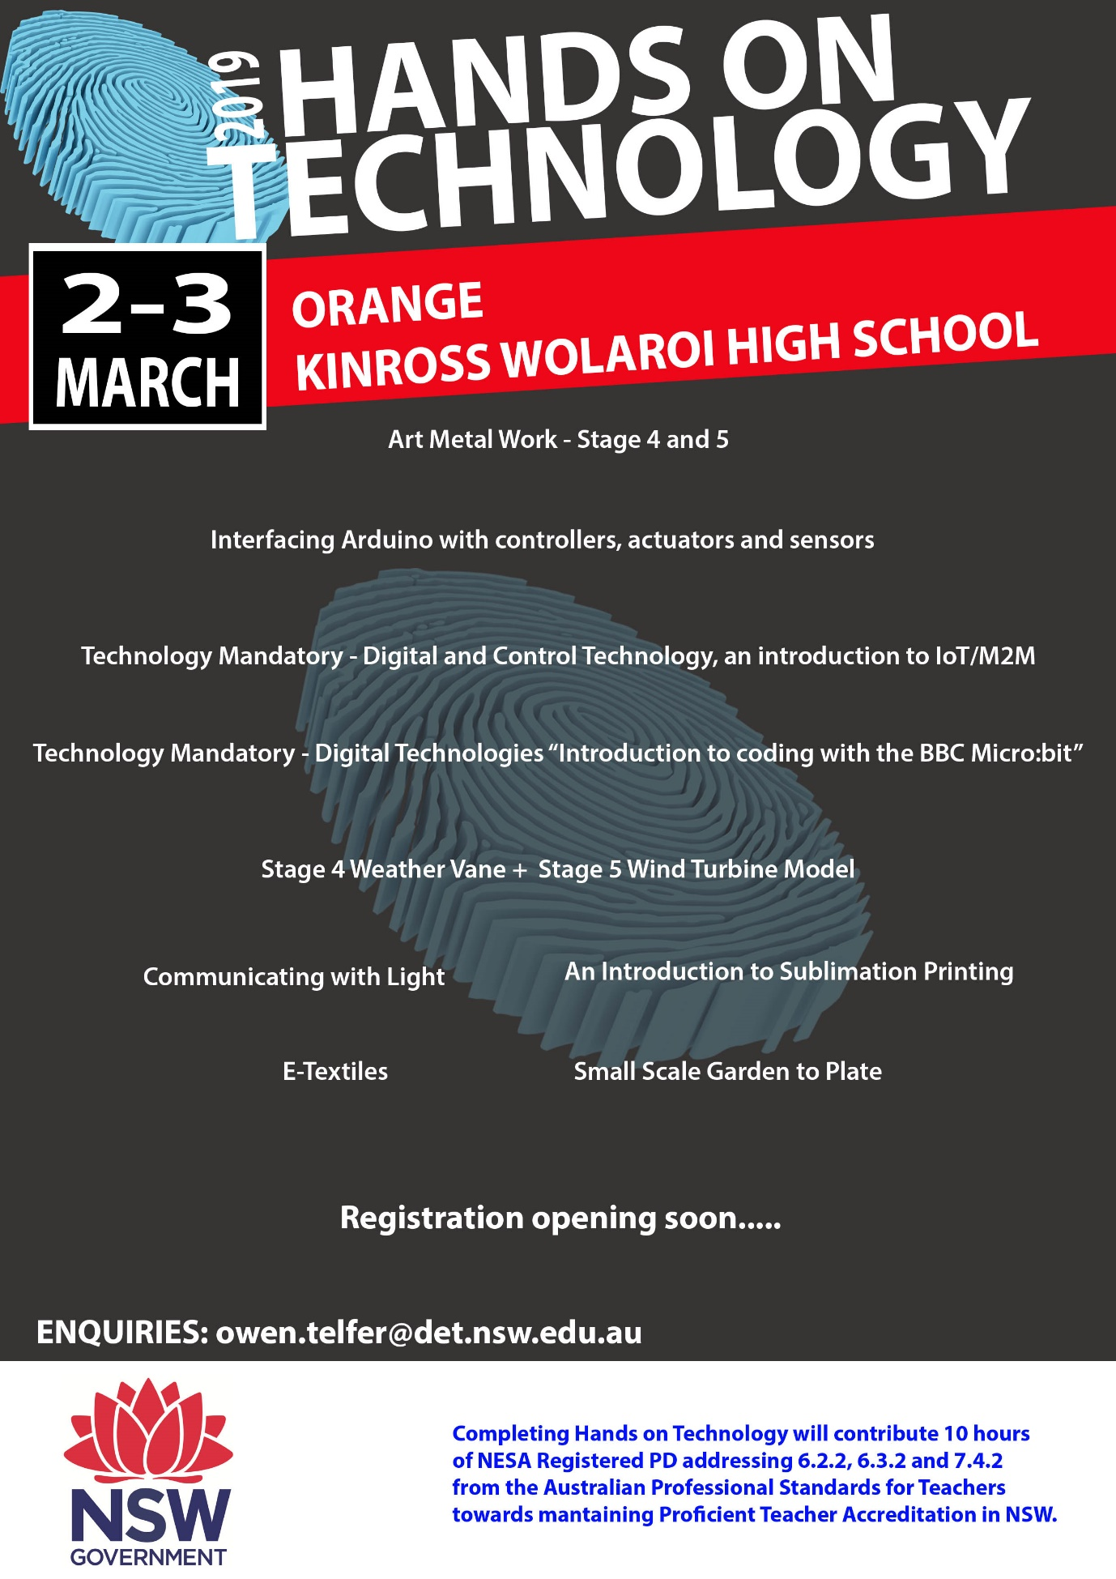

Kinross Wolaroi High  2nd/3rd March 2019 | Course Description | Participants  Numbers | Cost
Technology Mandatory - Digital Technologies  ‘Introduction to coding with the BBC Micro:bit’ | Throughout this course we will be using a small programmable computer called the Micro:bit. You will use Micro:bit software and the Micro:bit microcontroller board to create your own digital technology projects using simple algorithms.  Course participants will receive a Micro:bit microcontroller plus a student workbook (printed version in colour plus PDF) covering an introduction to the Micro:bit and 6 coding activities, plus 2 extension activities.  Activities include:  1. Turning on and controlling the LED display on the Micro:bit  2. Using buttons to control the Micro:bit LED display  3. Screen rotation exercise  4. Fridge door-light and alarm  5. Rock Paper Scissors Game  6. Traffic light sequencing using the external pins on the Micro:bit  7. Setting up a simple compass using the Micro:bit – extension activity  8. Attaching a servo to the Micro:bit – extension activity  Each activity is structured to introduce new coding skills and/or to consolidate on previously learnt coding skills. By completing the activities in the booklet your students should gain enough experience to complete the design project at the end of this unit.  Participants will receive:  · a printed student work-booklet plus a PDF copy;  · complete electronic files of all activities listed above; and  · a Micro:bit controller including USB cable and battery pack. | 20 MAX | $450
Art Metal Work - Stage 4 and 5 | This course is intended for those who have never done silver jewellery making before and are looking to introduce it as a Stage 4 option in Technology Mandatory. You will learn how to make a plain silver ring, a twisted ring and a pendant in sterling silver. This is taught from metalworking principles and can be taught in a metalwork room with basic tools. | 15 MAX | $450
Engineering Mechanisms – Weather Vane  Alternative Energy – Wind Turbine Model | This workshop has 2 parts to it,  Part 1: STAGE 4 Engineered Systems focusing on Mechanisms – Weather Vane  This workshop is aimed at demonstrating the STEM principles embedded in Stage 4 Technology Mandatory through making a Weather Vane. Building weather vanes is a great way to learn about mechanisms including cams and cranks. You will build a working, wind powered weather vane attached to a humorous animated character. You will be provided with an assessment task and program that can be modified to suit your school context.  Part 2: STAGE 5 Alternative Energy – Wind Turbine Model  This workshop is aimed at demonstrating the STEM principles embedded in Stage 5 Industrial Technology - Engineering through making a Wind turbine. Studying wind turbines is a great way to learn about renewable energy generation. You will build a working wind turbine model and then compare the amount of electricity produced by high and low wind speeds. You will be provided with an assessment task and program that can be modified to suit your school context. | 15 MAX | $500
Communicating with Light | Light is a common medium for communicating information. This session will involve the use of basic electronic skills to create a device that will transmit to a solar cell. How far will you be able to send your message? A great project that you will be able to use with Stage 4 – 6 students, in Technology, STEM and Engineering Studies. This course is intended for those that have done little electronic work previously. It has many fascinating variations that will allow you to present this work to a wide range of students. | 20 MAX | $400
An Introduction to Sublimation Printing | Sublimation printing uses heat to transfer dye to materials such as fabric, ceramics, timber and metal. In this session you will learn some introductory techniques to enable the implementation of projects using Adobe Photoshop and Illustrator to create designs. The skills and projects can be applied to Stages 4, 5 and 6 in subject areas including Technology, Design and Technology, Industrial Technology, Textiles Technology and Textiles and Design. Participants will produce sample projects to take away with them. Participants are asked to bring their own laptop. | 12 MAX | $450
Interfacing Arduino with controllers, actuators and sensors | In this course, you will make three simple projects:  - a simple robotic arm;  - a simple automatic opening garbage bin; and  - a room proximity sensor triggered by distance.  This course teaches the basics of interfacing sensors to the Arduino board and provides some Industrial Technology - Engineering control systems/mechanisms projects as well as a Stage 4 coding project.  Note: Participants will need to supply a laptop. | 18 MAX | $450
Small Scale Garden to Plate | From garden to plate, small sustainable produce can be grown to create innovative and exciting classroom food units in the new Stage 4 Technology syllabus. Participants will use a variety of seasonal ideas for creative dishes, which can be scaffolded for a classes of mixed skills and abilities. The course is intended for those that have had little experience with garden to plate inspirations. | 12 MAX | $450
etextiles | This is a STEM course designed to help the absolute beginner get going with e-Textiles. Teachers will be introduced to the basic concepts of electronics and how to apply them to textile based design projects (e-Textiles).  You will learn about:  - introductory electronics theory;  - identification of simple components;  - developing circuits using ICTs; and  - applying that knowledge to simple skill development projects.  Participants will engage in discussion regarding problem based learning, its application in the classroom and how to develop appropriate assessment methodologies.  Note: The workshop will include a kit of components that contains enough components to enable further experimentation after the course. | 20 MAX | $400
Digital and Control Technologies - an introduction to IoT/M2M | This workshop is an easy introduction to IOT/M2M Control Technologies. It addresses some Outcomes from the Digital Technologies, Engineered Systems and Materials Technologies Contexts of the new Technology Mandatory syllabus while learning to code a microprocessor. The course will introduce concepts of coding with real world devices, an introduction to microprocessors via a locally developed board with built in I/O, motor driver, multiple LEDs, LDR, buzzer output.  This is a low-cost entry appropriate to schools using free software for simulation and experimentation.  Course costs include 11 ‘Techstarter’ boards for use in the classroom. Additional sets are available for purchase.  Participants will engage in discussion regarding problem/project based learning, its application in the classroom and how to develop appropriate assessment methodologies.  Targeted concepts are Project Based Learning, Design Thinking, Computational and Algorithmic thinking and Integrated Learning. | 20 MAX | $600

